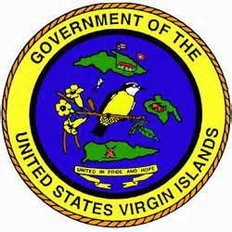
PRESS RELEASE
For Immediate Release For more information, contact:
July 8, 2020 Caroline F. Fawkes
Supervisor of Elections
Caroline.fawkes@vi.gov
(o) 340-773-1021
(c) 340-227-8827

***BOARD OF ELECTIONS MEETING NOTICE***

The Board of Elections has scheduled a Board Meeting for Tuesday, July 15, 2020 at 1:00pm. This meeting will be held via Microsoft Teams-teleconference/video-conference. Anyone interested in attending, please forward your email address for an invitation to participate via teleconference to Acting Deputy Supervisor of Elections (St. Croix district), terrell.alexandre@boel.vi.gov.

For questions or concerns, please contact the Elections System Offices on St. Croix (340) 773-1021 or St. Thomas (340) 774-3107.

For official election updates, visit our website at www.vivote.gov.

###

